**Analysis Conclusions**

The final KNIME workflow is shown below:

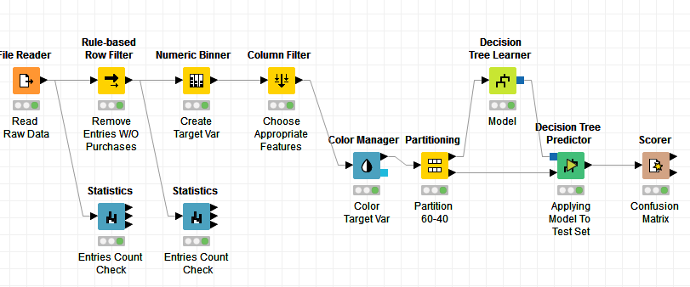

What makes a HighRoller vs. a PennyPincher?

* High Rollers:
  + Iphone users
* Penny Pinchers
  + The remaining platforms’ users

|  |
| --- |
| **Specific Recommendations to Increase Revenue** |
| 1. Promote **special promotions** of in-app purchases & **increase number of ads** to users of platforms other than Iphone |
| 2. Send **thank you email** to Iphone users for their purchases and **send vouchers** to them to encourage them to keep on spending |